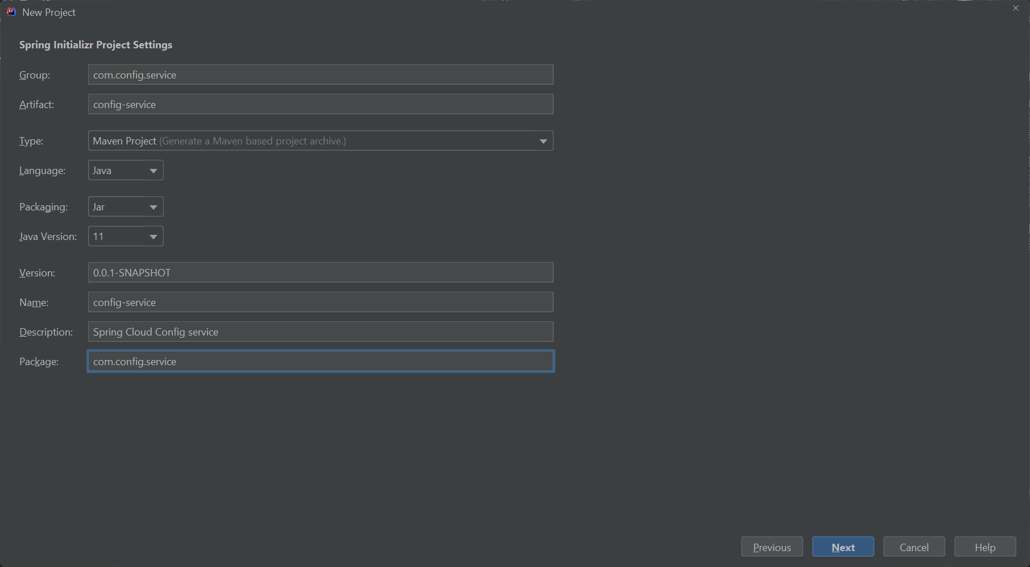

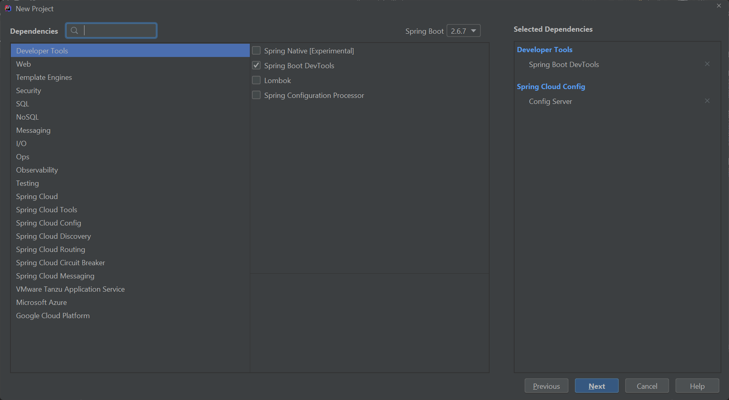

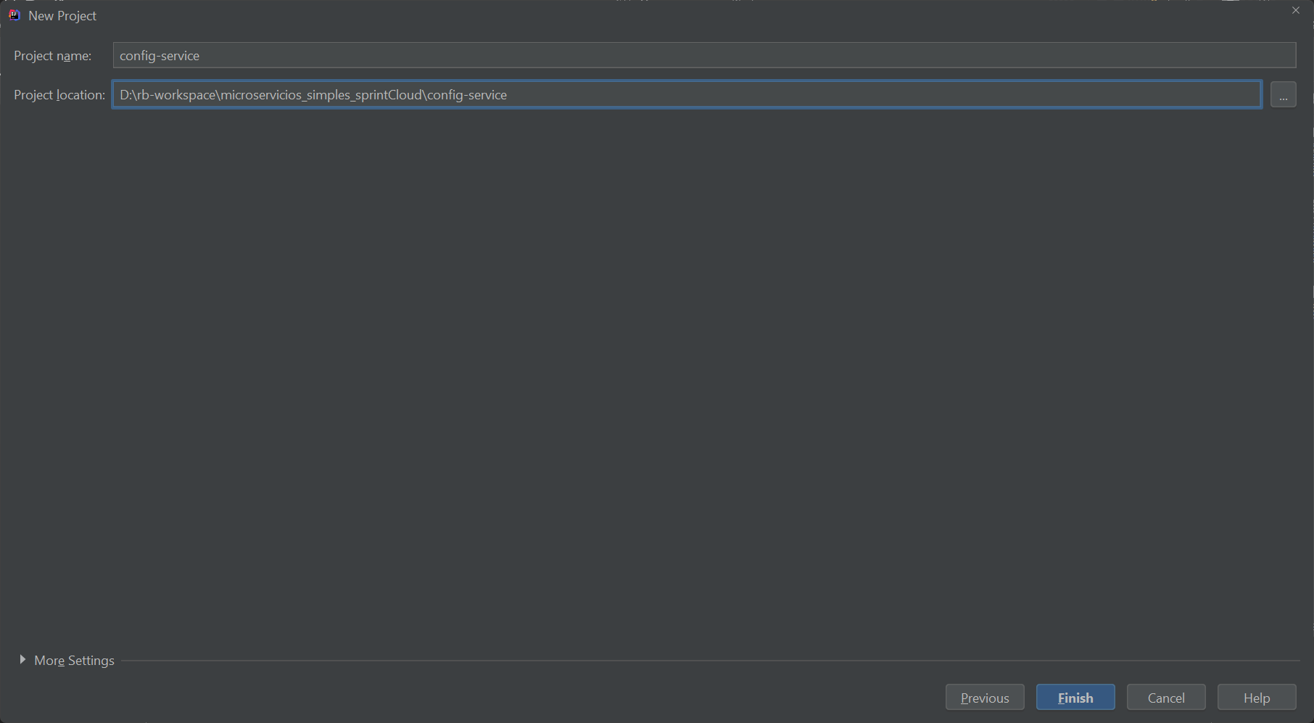

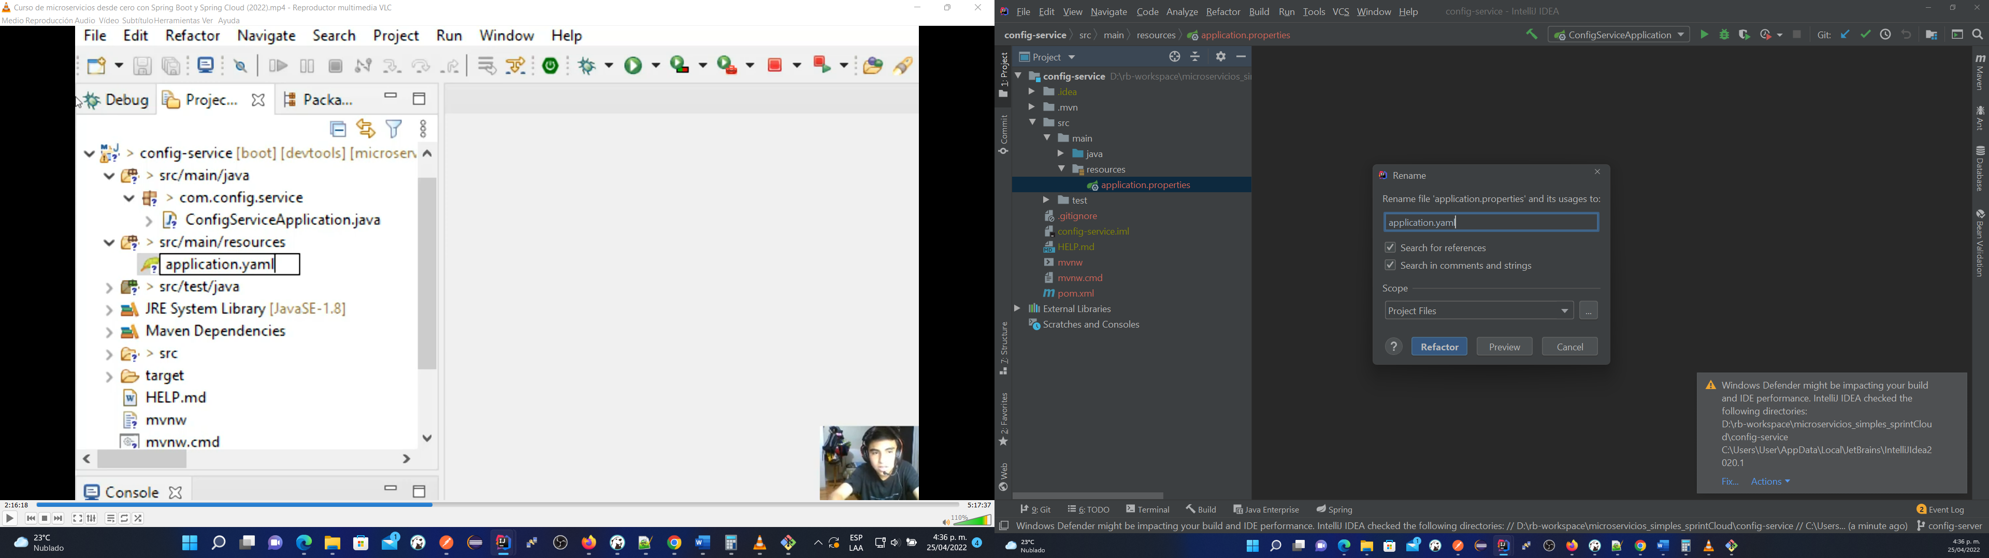

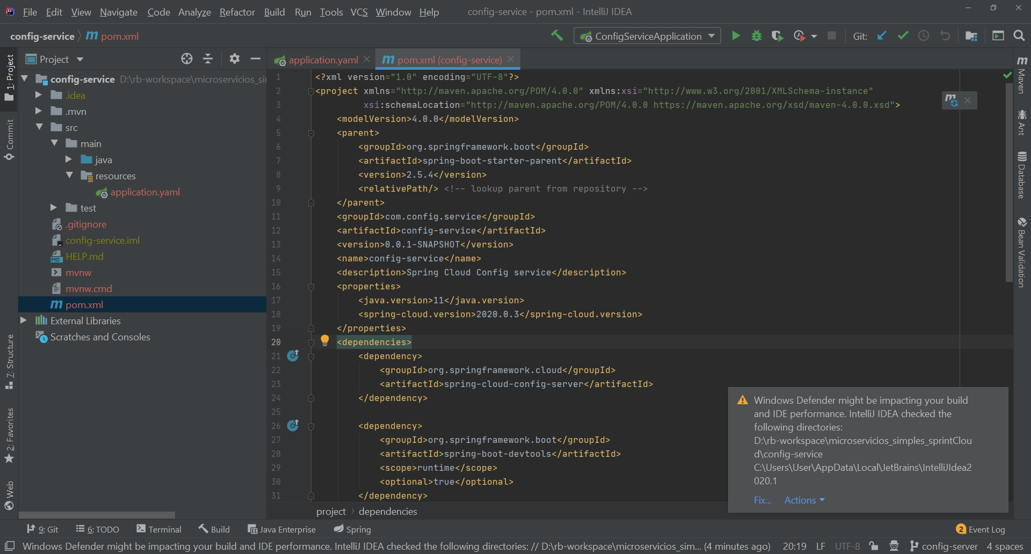

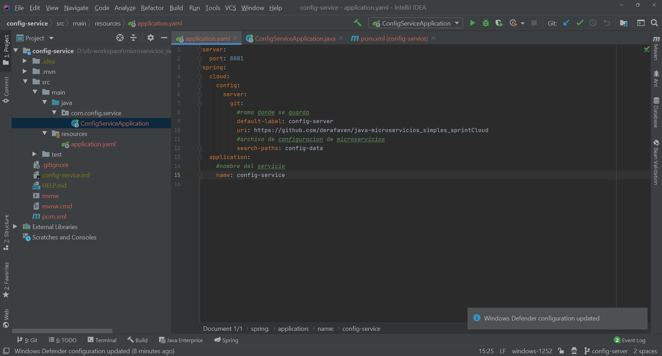

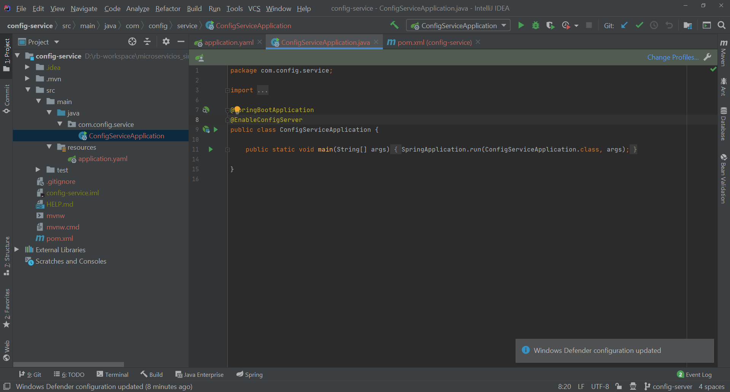

User@DESKTOP-02K3V5A MINGW64 /d/rb-workspace/microservicios_simples_sprintCloud (config-server)

$ mkdir config-data

User@DESKTOP-02K3V5A MINGW64 /d/rb-workspace/microservicios_simples_sprintCloud (config-server)

$ cd config-data

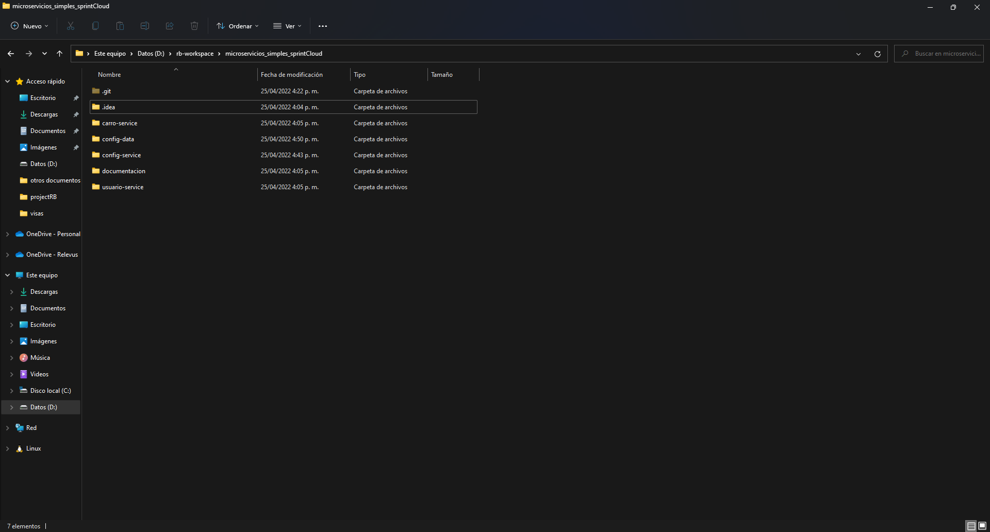

User@DESKTOP-02K3V5A MINGW64 /d/rb-workspace/microservicios_simples_sprintCloud/config-data (config-server)

$ touch usuario-service.yaml

User@DESKTOP-02K3V5A MINGW64 /d/rb-workspace/microservicios_simples_sprintCloud/config-data (config-server)

$ touch carro-service.yaml

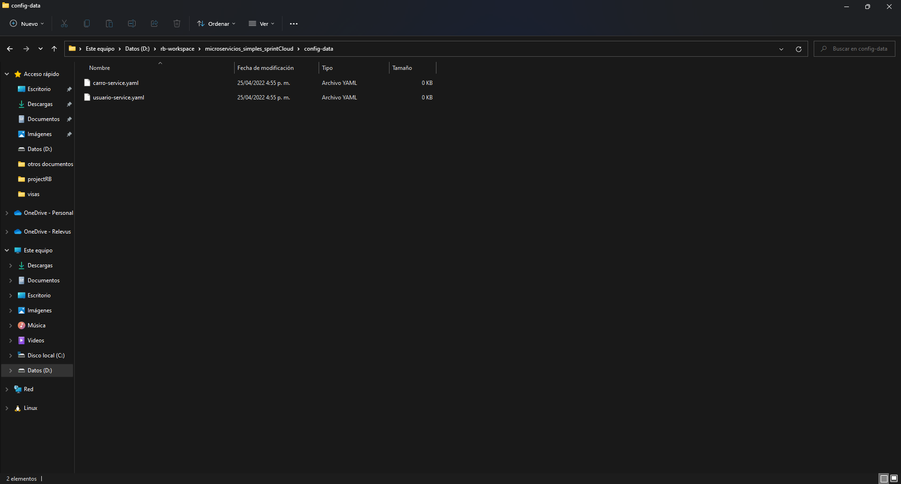

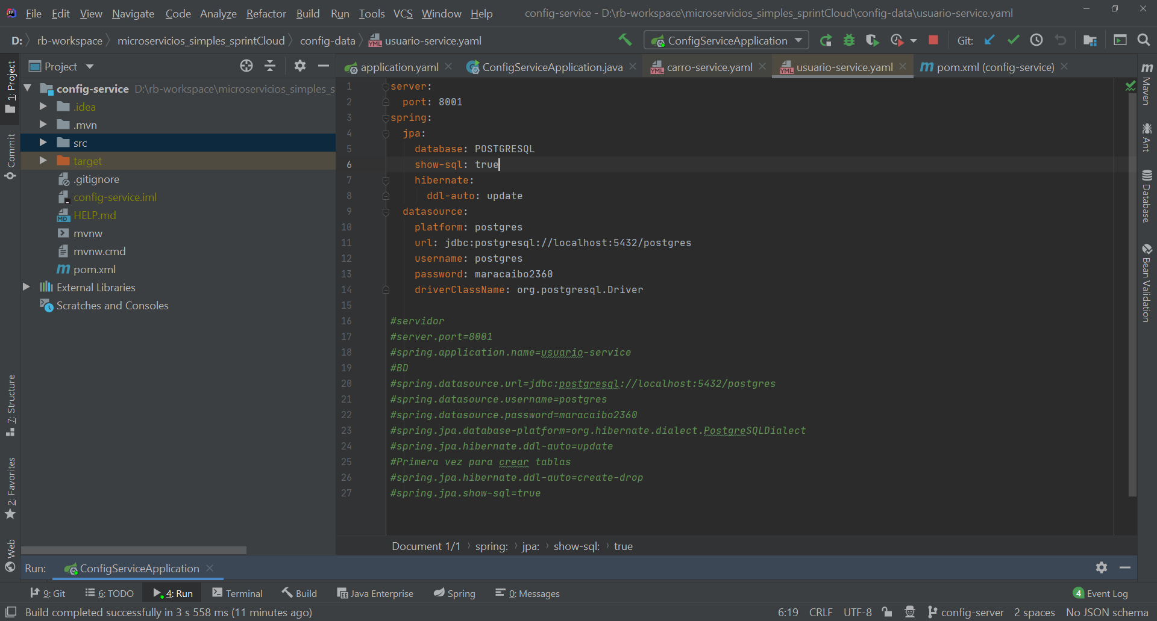

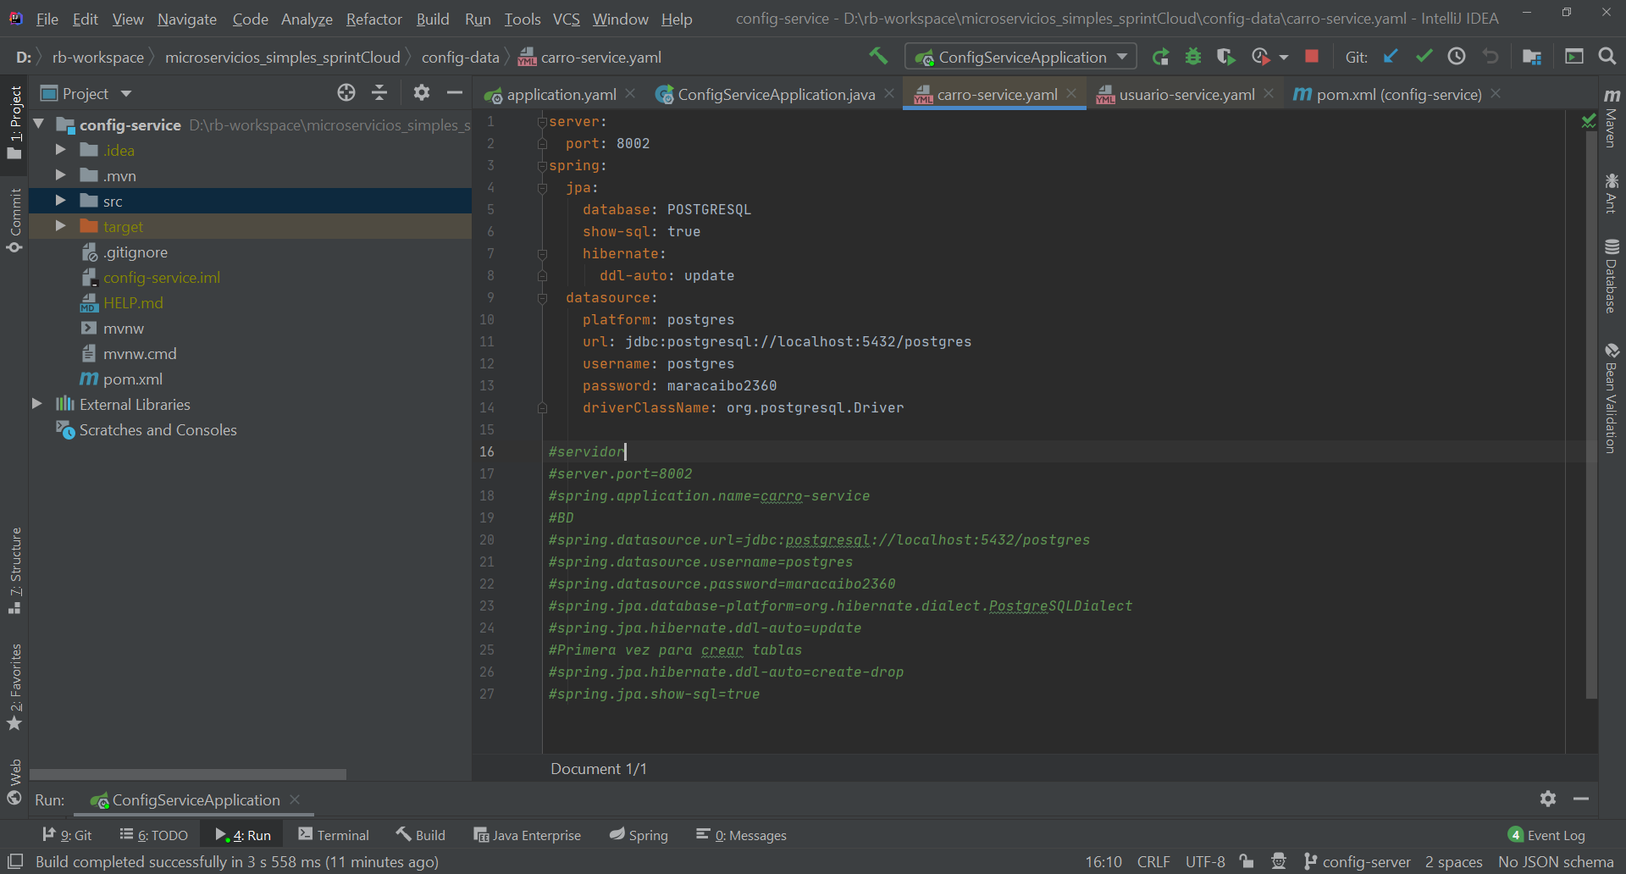

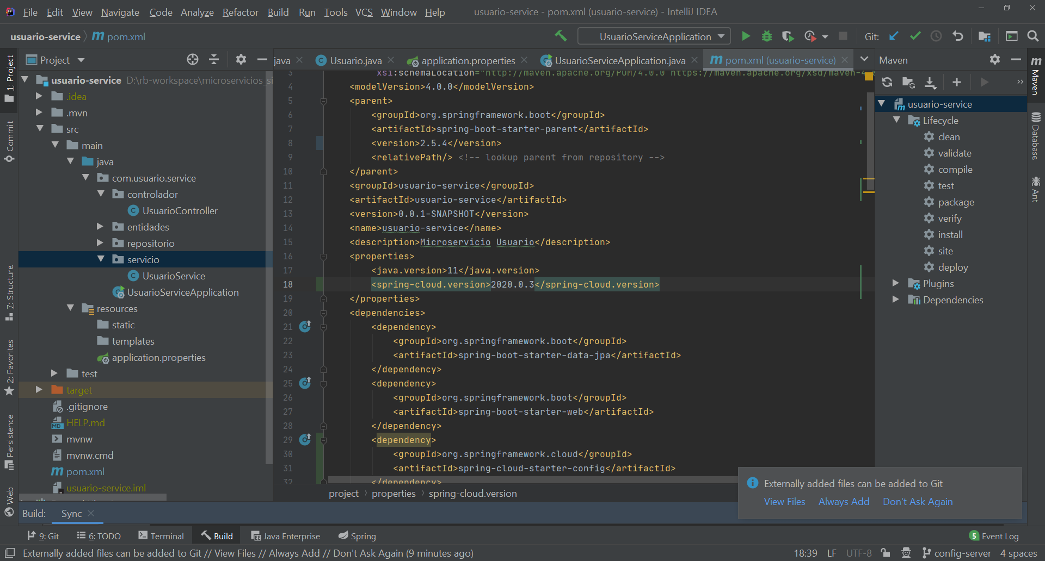

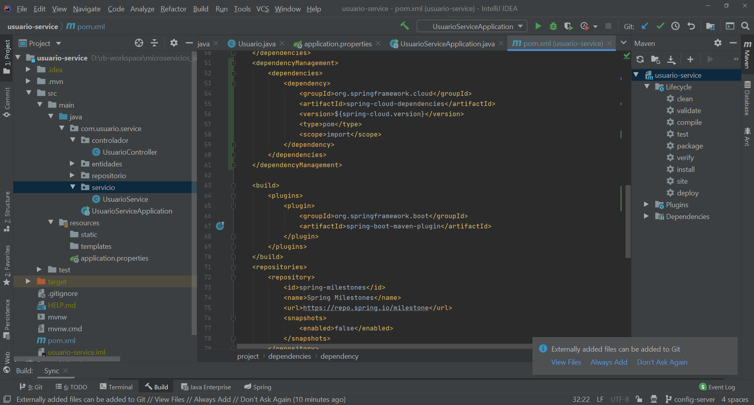

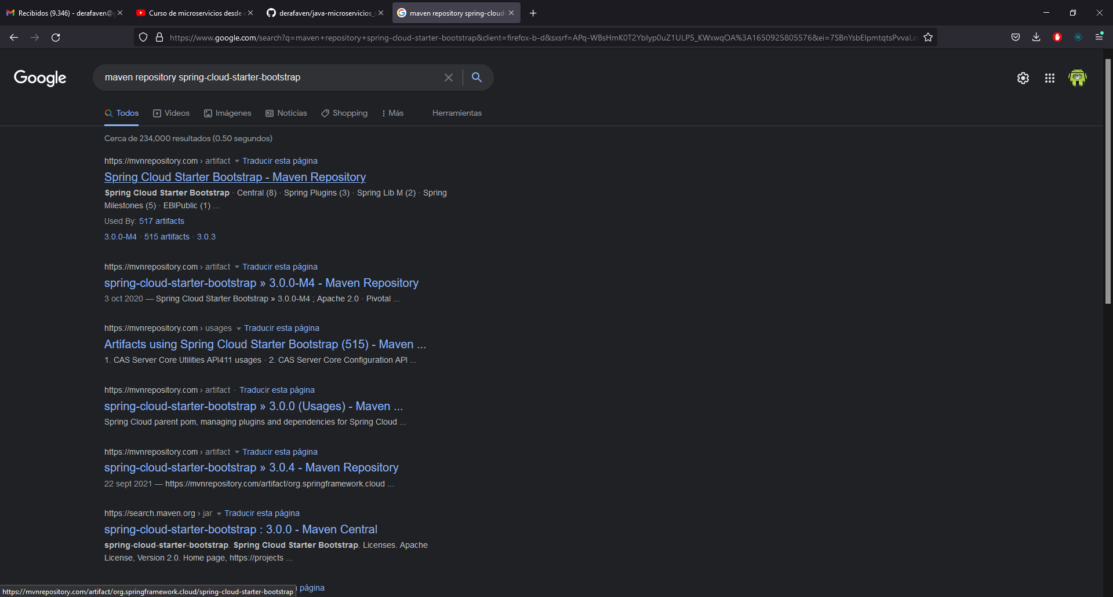

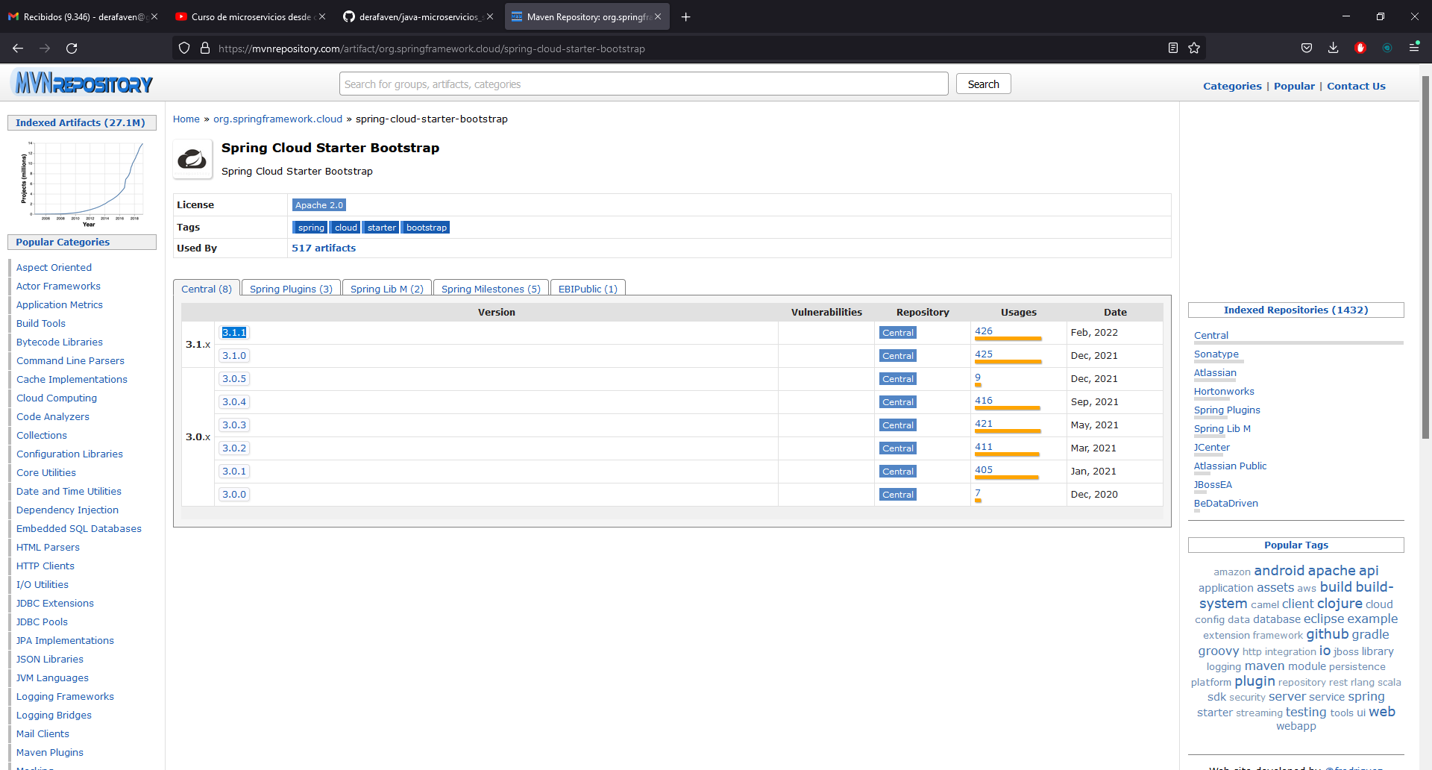

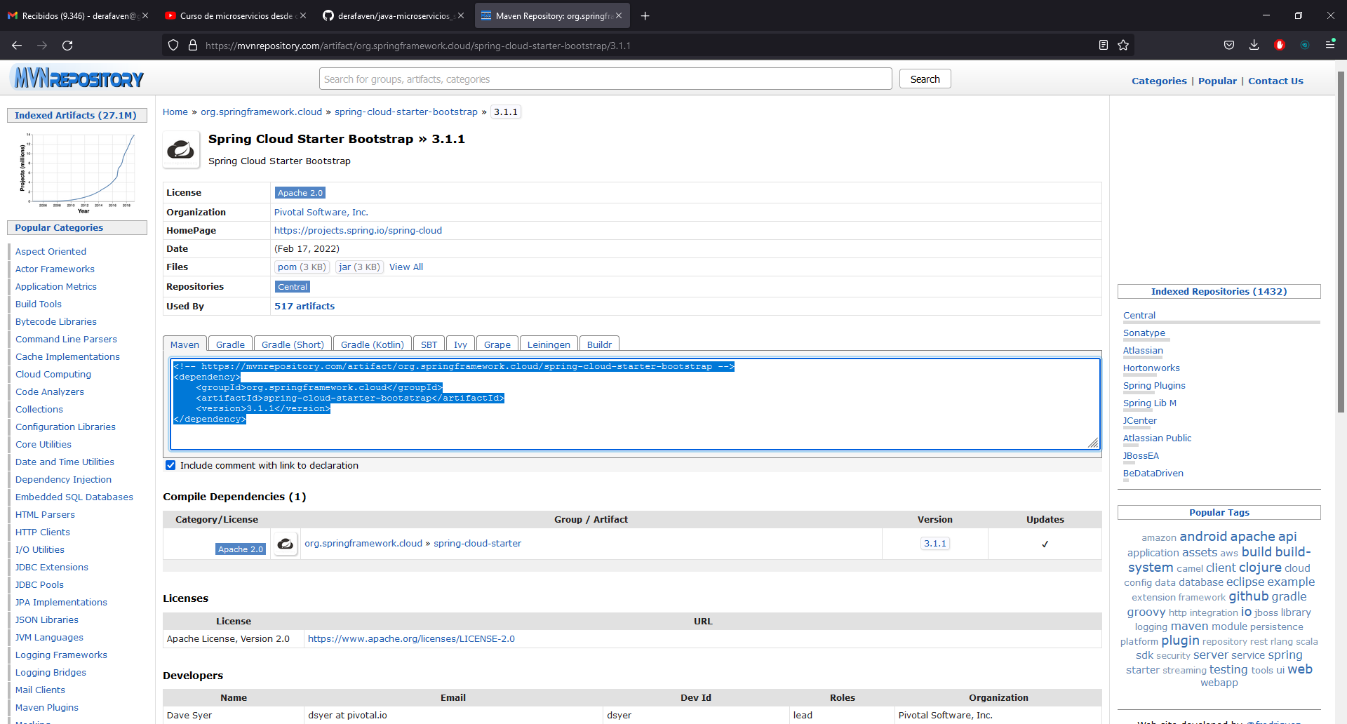

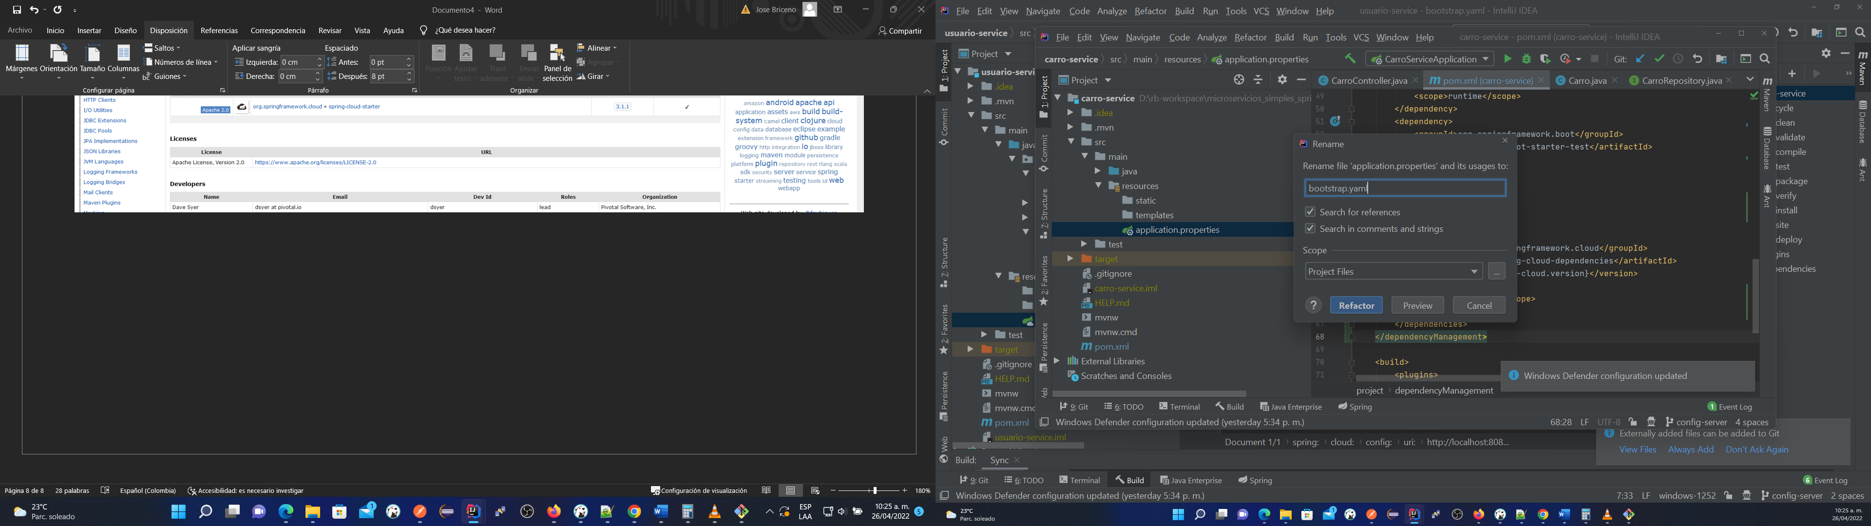

User@DESKTOP-02K3V5A MINGW64 /d/rb-workspace/microservicios_simples_sprintCloud/config-data (config-server)

$ cd ..

User@DESKTOP-02K3V5A MINGW64 /d/rb-workspace/microservicios_simples_sprintCloud (config-server)

$ git add .

warning: LF will be replaced by CRLF in carro-service/pom.xml.

The file will have its original line endings in your working directory

warning: LF will be replaced by CRLF in usuario-service/pom.xml.

The file will have its original line endings in your working directory

warning: LF will be replaced by CRLF in usuario-service/src/main/resources/bootstrap.yaml.

The file will have its original line endings in your working directory

warning: LF will be replaced by CRLF in config-service/.gitignore.

The file will have its original line endings in your working directory

warning: LF will be replaced by CRLF in config-service/.mvn/wrapper/maven-wrapper.properties.

The file will have its original line endings in your working directory

warning: LF will be replaced by CRLF in config-service/mvnw.

The file will have its original line endings in your working directory

warning: LF will be replaced by CRLF in config-service/mvnw.cmd.

The file will have its original line endings in your working directory

warning: LF will be replaced by CRLF in config-service/pom.xml.

The file will have its original line endings in your working directory

warning: LF will be replaced by CRLF in config-service/src/main/java/com/config/service/ConfigServiceApplication.java.

The file will have its original line endings in your working directory

warning: LF will be replaced by CRLF in config-service/src/main/resources/application.yaml.

The file will have its original line endings in your working directory

warning: LF will be replaced by CRLF in config-service/src/test/java/com/config/service/ConfigServiceApplicationTests.java.

The file will have its original line endings in your working directory

warning: LF will be replaced by CRLF in demo/.gitignore.

The file will have its original line endings in your working directory

warning: LF will be replaced by CRLF in demo/.mvn/wrapper/maven-wrapper.properties.

The file will have its original line endings in your working directory

warning: LF will be replaced by CRLF in demo/mvnw.

The file will have its original line endings in your working directory

warning: LF will be replaced by CRLF in demo/mvnw.cmd.

The file will have its original line endings in your working directory

warning: LF will be replaced by CRLF in demo/pom.xml.

The file will have its original line endings in your working directory

warning: LF will be replaced by CRLF in demo/src/main/java/com/example/demo/DemoApplication.java.

The file will have its original line endings in your working directory

warning: LF will be replaced by CRLF in demo/src/main/resources/application.properties.

The file will have its original line endings in your working directory

warning: LF will be replaced by CRLF in demo/src/test/java/com/example/demo/DemoApplicationTests.java.

The file will have its original line endings in your working directory

User@DESKTOP-02K3V5A MINGW64 /d/rb-workspace/microservicios_simples_sprintCloud (config-server)

$ git commit -m "2 commit"

[config-server 6af248a] 2 commit

21 files changed, 1328 insertions(+), 22 deletions(-)

create mode 100644 config-service/.gitignore

create mode 100644 config-service/.mvn/wrapper/maven-wrapper.jar

create mode 100644 config-service/.mvn/wrapper/maven-wrapper.properties

create mode 100644 config-service/mvnw

create mode 100644 config-service/mvnw.cmd

create mode 100644 config-service/pom.xml

create mode 100644 config-service/src/main/java/com/config/service/ConfigServiceApplication.java

create mode 100644 config-service/src/main/resources/application.yaml

create mode 100644 config-service/src/test/java/com/config/service/ConfigServiceApplicationTests.java

create mode 100644 demo/.gitignore

create mode 100644 demo/.mvn/wrapper/maven-wrapper.jar

create mode 100644 demo/.mvn/wrapper/maven-wrapper.properties

create mode 100644 demo/mvnw

create mode 100644 demo/mvnw.cmd

create mode 100644 demo/pom.xml

create mode 100644 demo/src/main/java/com/example/demo/DemoApplication.java

create mode 100644 demo/src/main/resources/application.properties

create mode 100644 demo/src/test/java/com/example/demo/DemoApplicationTests.java

rewrite usuario-service/src/main/resources/bootstrap.yaml (60%)

User@DESKTOP-02K3V5A MINGW64 /d/rb-workspace/microservicios_simples_sprintCloud (config-server)

$ git push -u origin config-server

Enumerating objects: 50, done.

Counting objects: 100% (50/50), done.

Delta compression using up to 8 threads

Compressing objects: 100% (26/26), done.

Writing objects: 100% (44/44), 4.58 KiB | 1.15 MiB/s, done.

Total 44 (delta 9), reused 0 (delta 0), pack-reused 0

remote: Resolving deltas: 100% (9/9), completed with 4 local objects.

To https://github.com/derafaven/java-microservicios_simples_sprintCloud.git

5e73501..6af248a config-server -> config-server

Branch 'config-server' set up to track remote branch 'config-server' from 'origin'.

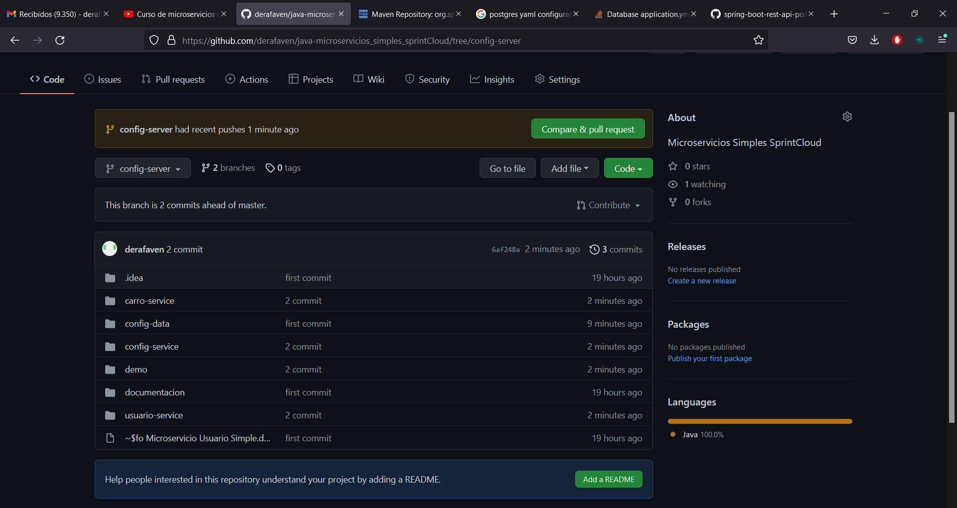

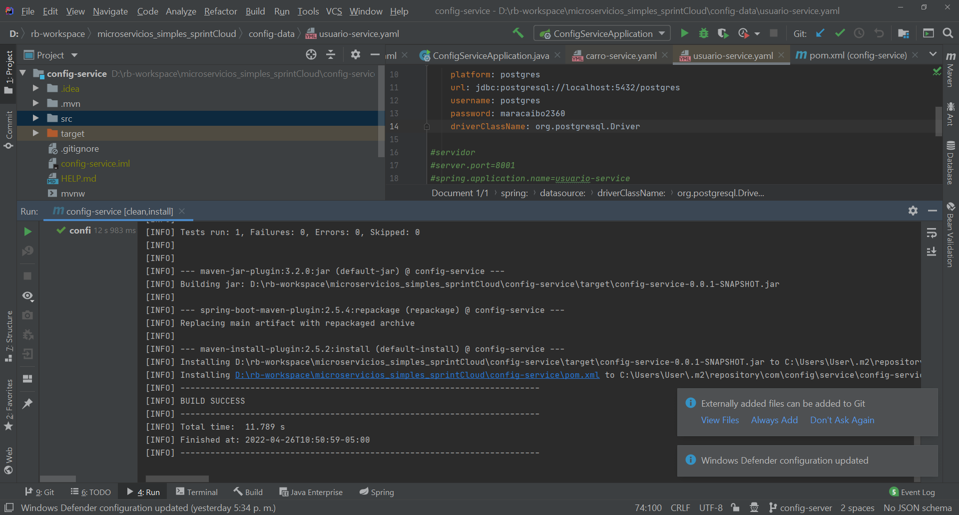

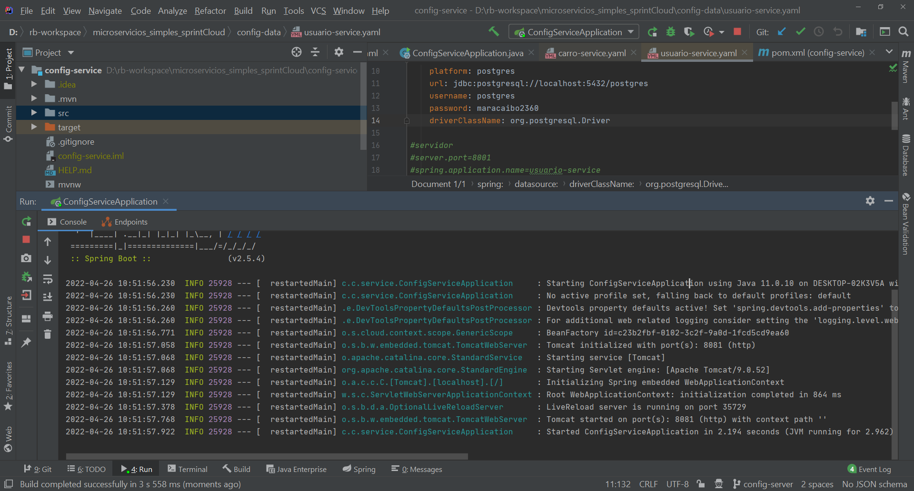

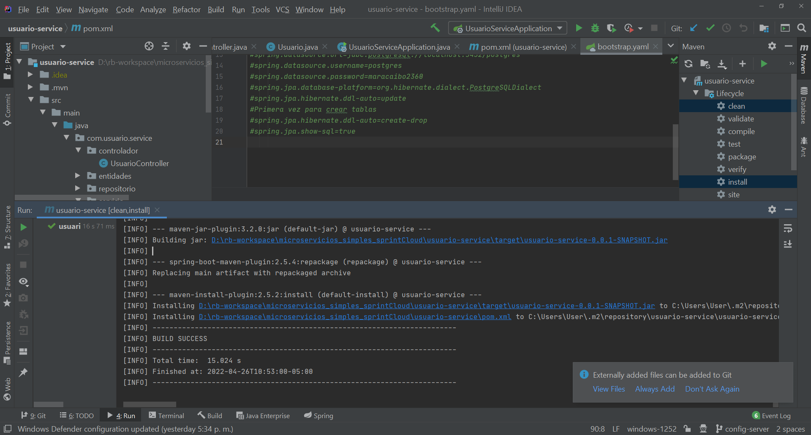

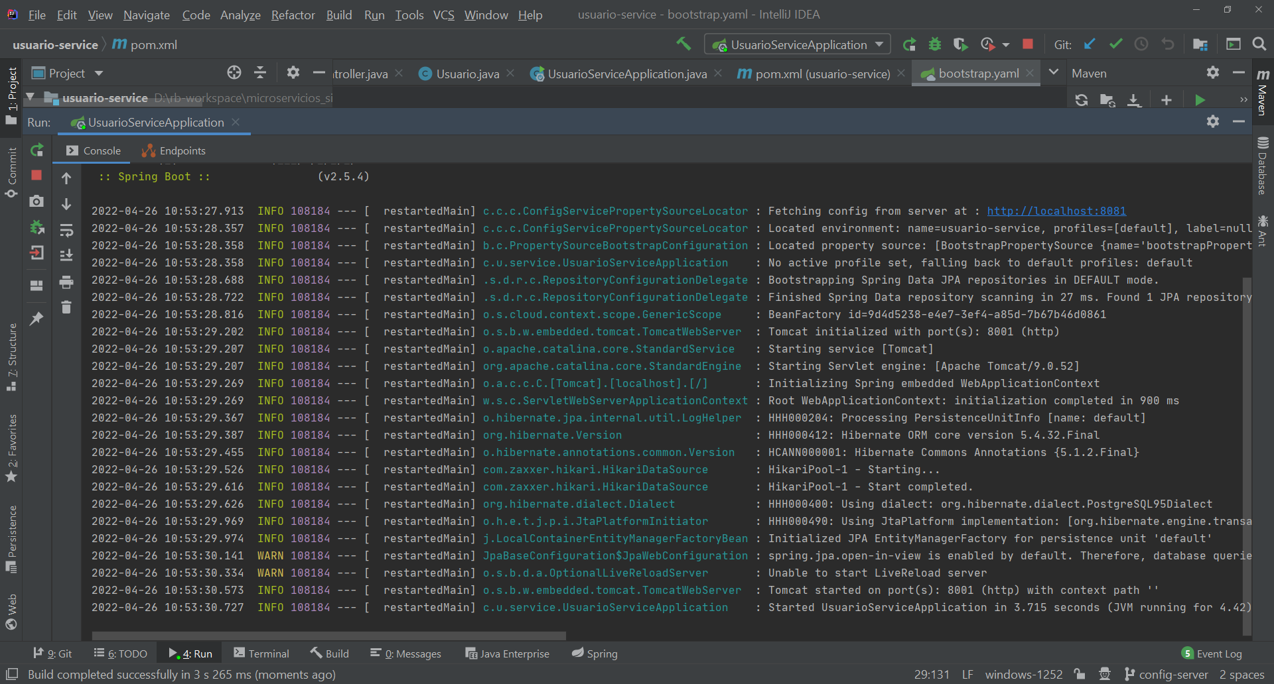

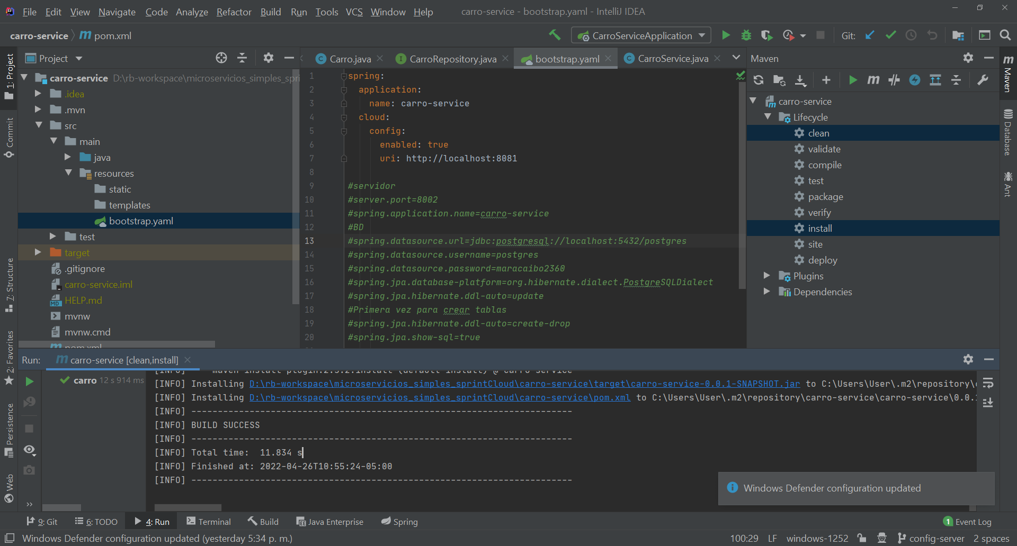

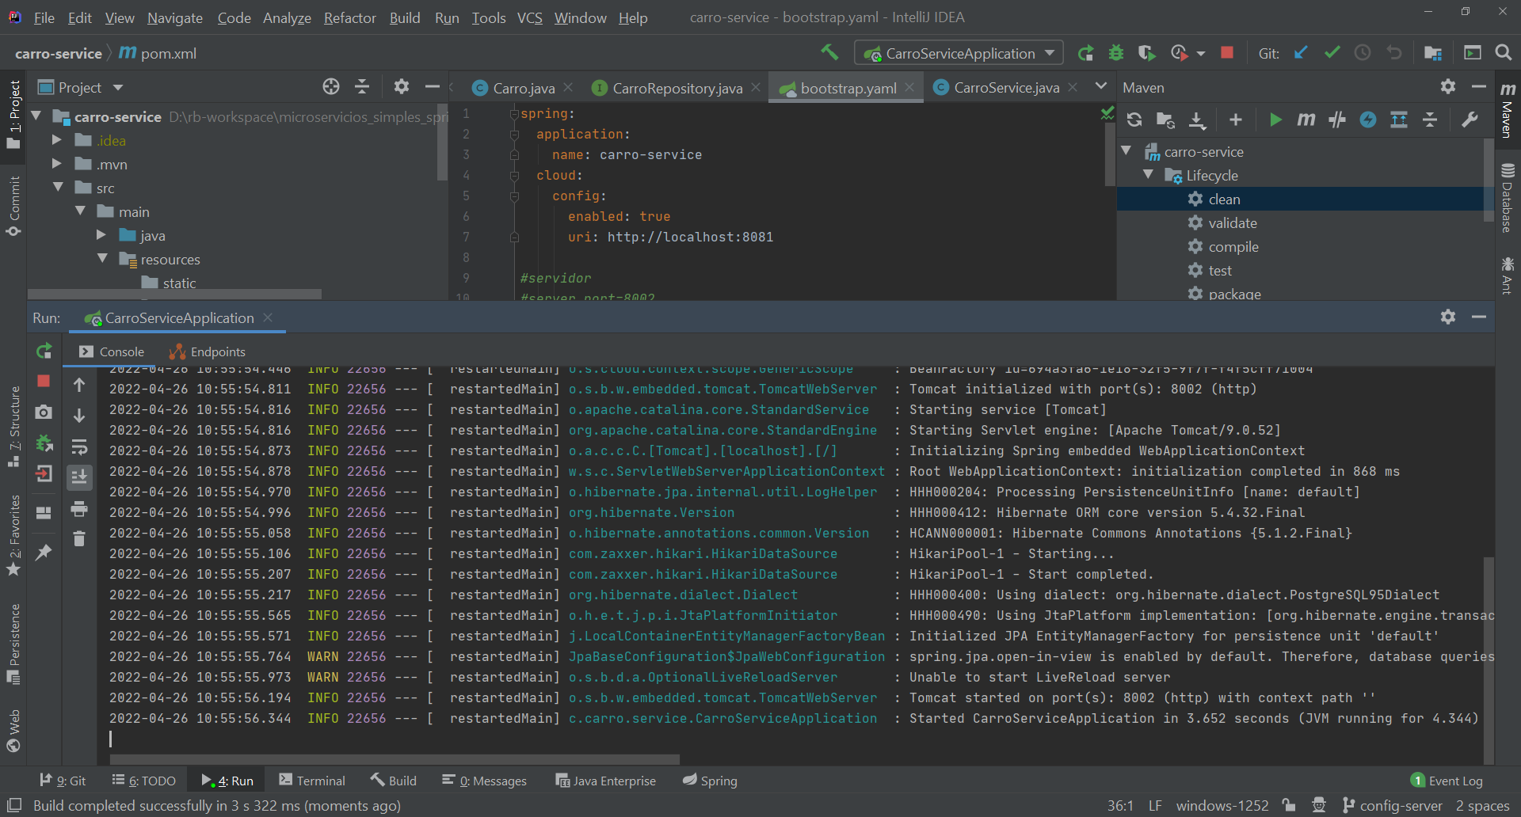

Pruebas

